First time training
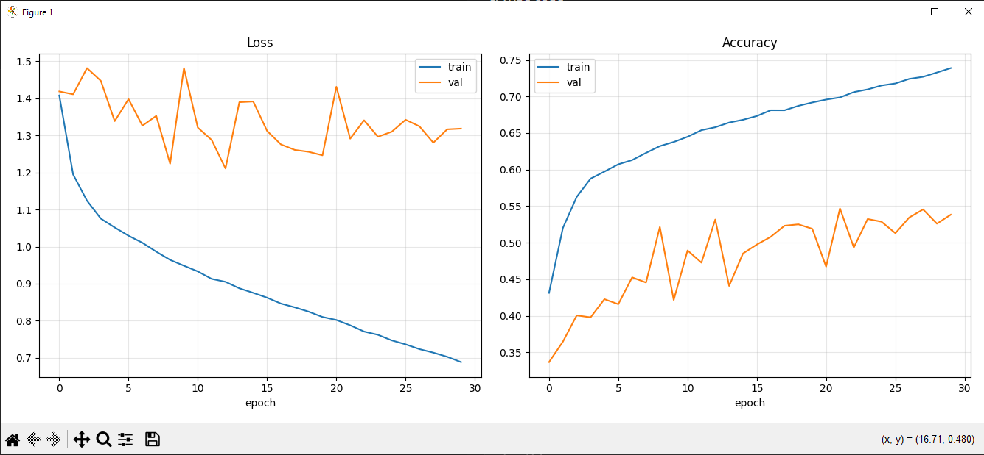
python train.py --epochs 30 --batch-size 32 --lr 0.001

sec time training
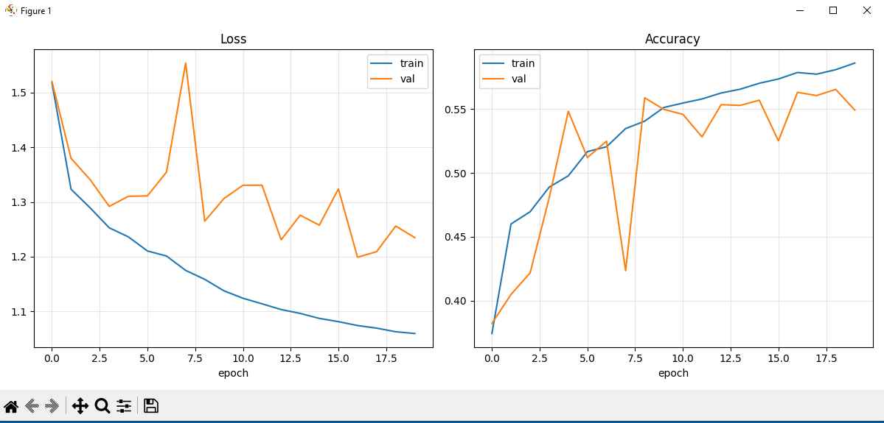python train.py --epochs 20 --hidden-size 16 --batch-size 32 --lr 0.001

3-time training
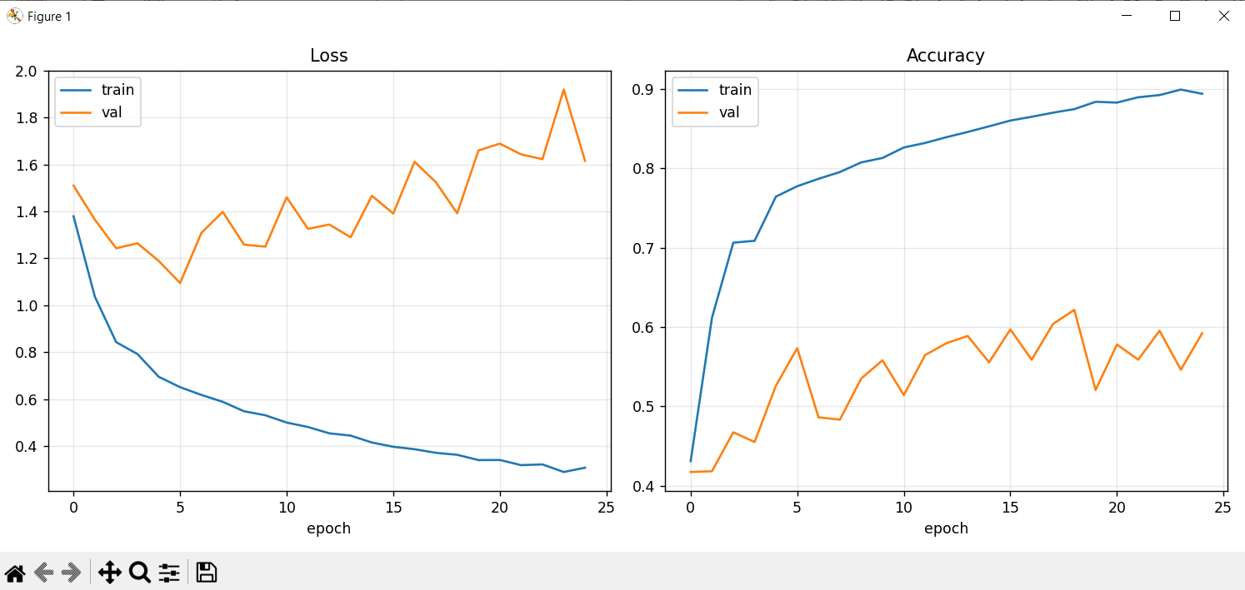
python train.py --epochs 25 --hidden-size 32 --batch-size 32 --lr 0.001

4-time training
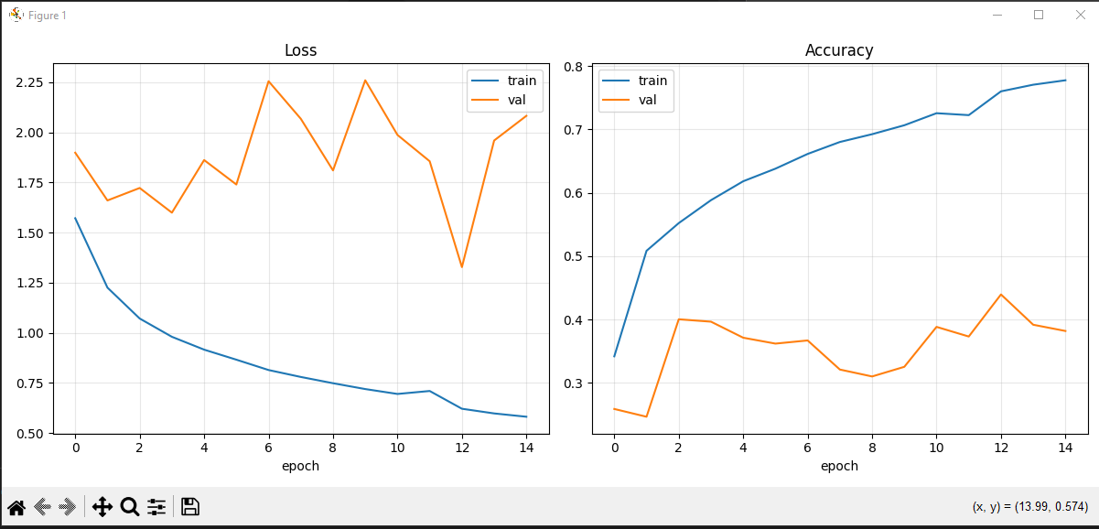 python train.py --epochs 15 --hidden-size 16 --batch-size 32 --lr 0.001

